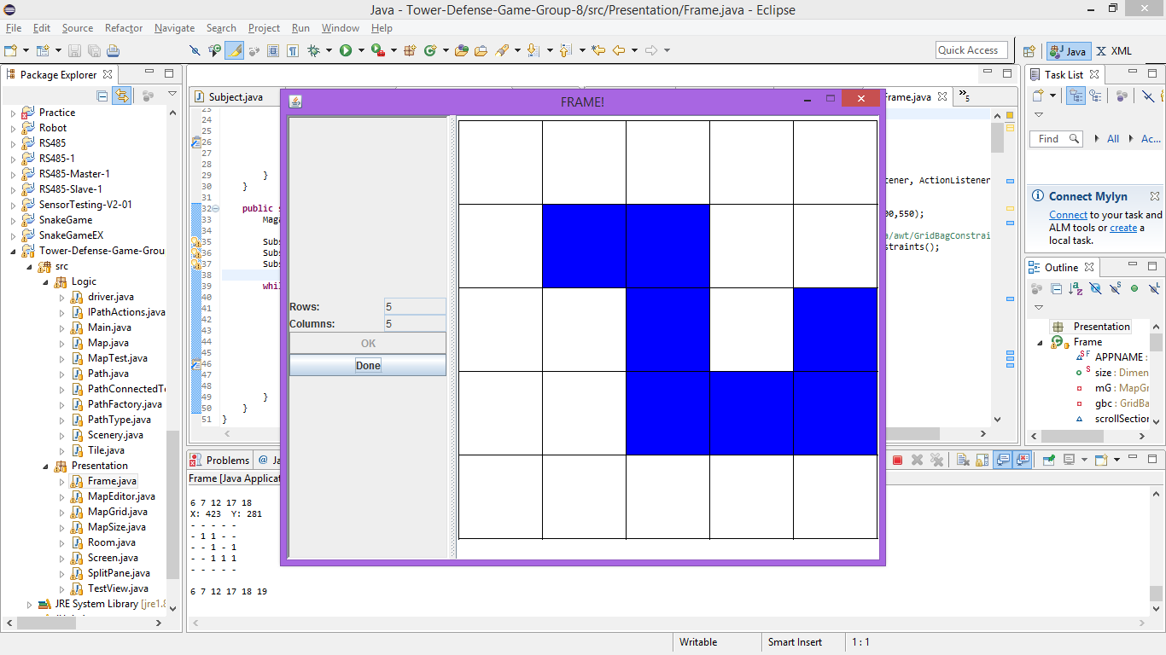

|  |  |  |  |  |
| --- | --- | --- | --- | --- |
|  |  |  |  |  |
|  |  |  |  |  |
|  |  |  |  |  |
|  |  |  |  |  |
|  |  |  |  |  |

All the position of each map item is with respect to the above table.

This is to place the path(6, 7, 12, 17, 18, 19) . The grid should incrementally output this:

- - - - -

- 1 - - -

- - - - -

- - - - -

- - - - -

- - - - -

- 1 1 - -

- - - - -

- - - - -

- - - - -

- - - - -

- 1 1 - -

- - 1 - -

- - - - -

- - - - -

- - - - -

- 1 1 - -

- - 1 - -

- - 1 - -

- - - - -

- - - - -

- 1 1 - -

- - 1 - -

- - 1 1 -

- - - - -

- - - - -

- 1 1 - -

- - 1 - -

- - 1 1 1

- - - - -

This is the finalized Map:

0 0 0 0 0

0 1 1 0 0

0 0 1 0 0

0 0 1 1 1

0 0 0 0 0

Placing the Towers:

0 0 0 0 0

0 1 1 0 0

2 0 1 0 0

0 0 1 1 1

0 0 0 0 0

0 0 0 0 0

0 1 1 0 0

2 0 1 0 0

0 0 1 1 1

2 0 0 0 0

0 0 0 0 0

0 1 1 0 0

2 0 1 0 0

2 0 1 1 1

2 0 0 0 0

0 0 0 0 0

0 1 1 0 2

2 0 1 0 0

2 0 1 1 1

2 0 0 0 0